|  |  |
| --- | --- |
| **Ex. No. 2** | **Working with HTML5 Form and Media Elements** |
| **Date of Exercise** | **19.07.23** |

**Aim**

To create a html page for html application form and media elements that conforms to HTML features.

**Description**

* The HTML <form> element is used to create an HTML form for user input. The <form> element is a container for different types of input elements, such as: text fields, checkboxes, radio buttons, submit buttons, etc.
* The <label> tag defines a label for many form elements. The form-data can be sent as URL variables (with method="get") or as HTTP post transaction (with method="post").
* Appends the form data to the URL, in name/value pairs, NEVER use GET to send sensitive data. The <input> element can be displayed in several ways, depending on the type attribute.
* The <label> element is useful for screen-reader users, because the screen-reader will read out loud the label when the user focuses on the input element.The <input type="submit"> defines a button for submitting the form data to a form-handler.
* Multimedia elements (like audio or video) are stored in media files. The HTML <video> element is used to show a video on a web page. The HTML <audio> element is used to play an audio file on a web page.
* Define an <iframe> element in your web page, Let the src attribute point to the video URL. Use the width and height attributes to specify the dimension of the player. Add any other parameters to the URL.

**Program**

**Media Elements**

<!DOCTYPE html>

<html lang="en">

<head>

<meta charset="UTF-8">

<meta name="viewport" content="width=device-width, initial-scale=1.0">

<title>Media</title>

</head>

<body>

<h2 align="center" style = "color: blue">Company Name</h2>

<hr>

<a href = "media.html" style="margin-left: 620px;">Media Elements</a>

<a href = "Application.html" style="margin-left: 60px;">Application Form</a>

<hr>

<audio style="padding-left:650px;"src="song1.mp3.mp3" controls>Play Music</audio>

<hr>

<br><br>

<img src="https://karunya.edu/sites/default/files/img/infra/webs/TOP-VIEW-LOW.jpg.pagespeed.ce.zs6GySam-z.jpg" width="1050" height="450" alt="Karunya">

<iframe src="Ex_1A_DBMS.pdf" frameborder="0" width="500" height="300"></iframe>

<iframe width="560" height="315" src="https://www.youtube.com/embed/ktpG9OWzVPA" title="YouTube video player" frameborder="0" allow="accelerometer; autoplay; clipboard-write; encrypted-media; gyroscope; picture-in-picture; web-share" allowfullscreen></iframe>

<br><br>

<br><br>

<video src="C:\Users\HP\Downloads\Karunya, A Quick Preview in just 6 mins!.mp4" controls width="600" height="450" style="border:0;"></video>

<iframe src="https://www.google.com/maps/embed?pb=!1m18!1m12!1m3!1d3917.359813429757!2d76.74148607422471!3d10.936169256228576!2m3!1f0!2f0!3f0!3m2!1i1024!2i768!4f13.1!3m3!1m2!1s0x3ba866bd6aaaaaab%3A0xc650b8a75e7b51f0!2sKarunya%20Institute%20of%20Technology%20and%20Sciences%20(Deemed%20University)!5e0!3m2!1sen!2sin!4v1689834361108!5m2!1sen!2sin" width="600" height="450" style="border:0;" allowfullscreen="" loading="lazy" referrerpolicy="no-referrer-when-downgrade"></iframe>

</body>

</html>

**Application Form**

<!DOCTYPE html>

<html lang="en">

<head>

<meta charset="UTF-8">

<meta name="viewport" content="width=device-width, initial-scale=1.0">

<title>Application</title>

<link rel = "stylesheet" href = "ex2.css">

</head>

<body>

<hr>

<h2 align="center" style = "color: blue">Company Name</h2>

<hr>

<a href = "media.html" style="margin-left: 620px;">Media Elements</a>

<a href = "Application.html" style="margin-left: 60px;">Application Form</a>

<hr>

<fieldset>

<legend align="center">Form Title</legend>

<form action="">

<table width="50%" align="center">

<tr>

<td width="50%">

<label for="">Name</label>

</td>

<td width="50%">

<input type="text" name="name">

</td>

</tr>

<tr>

<td>

<label for="">Application Number</label>

</td>

<td>

<input type="text" name="applno">

</td>

</tr>

<tr>

<td width="50%">

<label for="pass">Password:</label>

</td>

<td width="50%">

<input type = "password" id = pass name ="password" pattern = "(? = *\d) (? =.*[a-z]) (?=.*[A-Z]),{8,}" required><br>

</td>

</tr>

<tr>

<td>

<label for="birthday">Date of Birth:</label>

</td>

<td>

<input type = "date" id ="Birthday" name = "birthday"><br>

</td>

</tr>

<tr>

<td width="50%">

<label for="age">Age:</label>

</td>

<td width="50%">

<input type="text" name="age"><br>

</td>

</tr>

<tr>

<td>

<label for="number">Mobile Number:</label>

</td>

<td>

<input type="text" name="number"><br>

</td>

</tr>

<tr>

<td width="50%">

<label for="email">Email:</label>

</td>

<td width="50%">

<input type="text" name="email"><br>

</td>

</tr>

<tr>

<td>

<label for="gender"> Gender:</label>

</td>

<td>

<input type = "radio" id ="Male" name = "male_gen" value="Male">

<label for = "Male">Male</label>

<input type = "radio" id ="Female" name = "female_gen" value ="Female">

<label for = "Female">Female</label><br>

</td>

</tr>

<tr>

<td width="50%">

<label for="comment">Address:</label>

</td>

<td width="50%">

<textarea id = "comment" name = "comment" rows = "3" cols = "20"></textarea>

</td>

</tr>

<tr width="100%">

<td>

<label>Languages Known</label>

</td>

<td width="100%">

<input type="checkbox">

<label>English</label>

<input type="checkbox">

<label>Tamil</label>

<input type="checkbox">

<label>Malayalam</label>

<input type="checkbox">

<label>Hindi</label>

<input type="checkbox">

<label>Telugu</label>

</td>

</tr>

<tr>

<td width="50%">

<label for="Course">Select your Course</label>

</td>

<td width="50%">

<select name = "Course" id = "cor">

<option value = "CSE">B.Tech Computer Science and Engineering</option>

<option value = "CSE">B.Tech Electronic Communication and Engineering</option>

<option value = "CSE">B.Tech Electrical and electronics Engineering</option>

<option value = "CSE">B.Tech Civil Engineering</option>

<option value = "CSE">B.Tech Mechanical Engineering</option>

</select>

</td>

</tr>

<tr>

<td>

<label for="img">Upload your Photo</label>

</td>

<td>

<input type="file" id = "img" name="img" accept="image/*">

</td>

</tr>

<tr>

<td>

</td>

<td>

<input type ="range" id ="vol" name = "vol" min="0" max="50">

<label>50% Uploading compeleted</label>

</td>

</tr>

<tr>

<td>

</td>

<td>

<input type = "button" onclick = "alert" value = "submit" />

</td>

</tr>

</table>

</form>

</fieldset>

</body>

</html>

**Output**

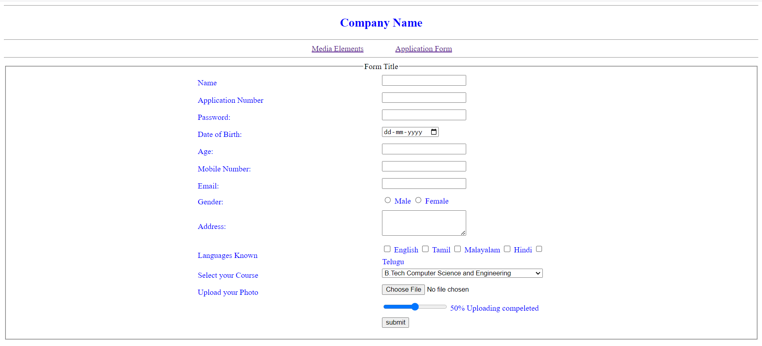

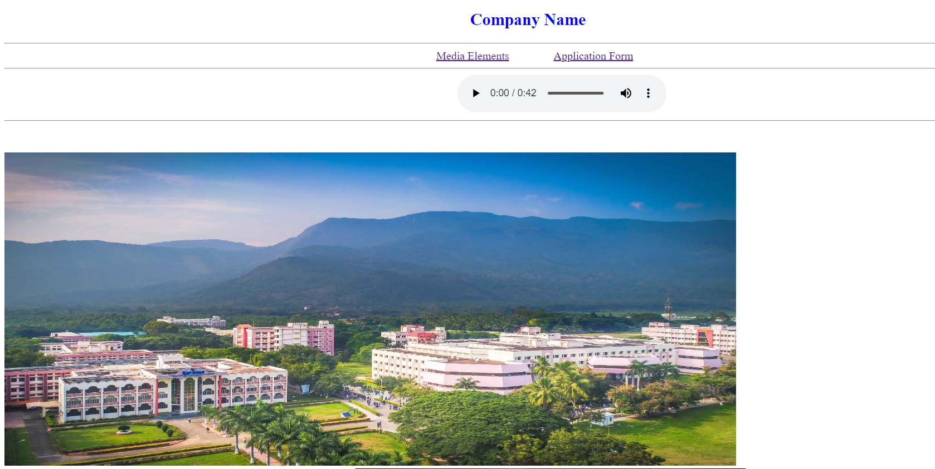

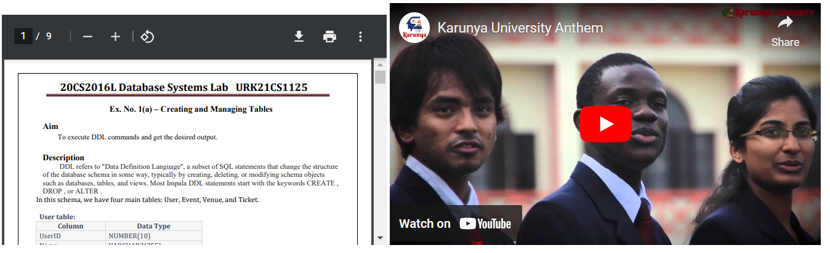



**Result**

The program is executed successfully and the program output is displayed in the web browser.